|  |  |
| --- | --- |
| cid:image004.png@01CF7F10.A4275880 | LOGO4 |
| Best Buy Canada Mobile | |
| |  | | --- | | **Warranty Feature Document** |   **Document Version: 1.3**  **Revision Date: April 1, 2015** | |
| **Prepared By: Amy Byers** | |

**Table of Contents**

*1.**Feature Overview* 3

1.1 Feature Description 3

1.2 Assumptions 3

1.3 Parameters and System Settings 3

1.4 Interfaces 4

*2.**USE CASE: Sell Warranty* 4

2.1 Feature Flow 4

2.2 Precondition 4

2.3 Main Flow 4

2.4 Alternate Flows 5

2.5 Post Condition 5

2.6 Special Requirements 5

*3.**USE CASE: Bundled Warranty* 7

3.1 Feature Flow 7

3.2 Precondition 7

3.3 Main Flow 7

3.4 Alternate Flows 8

3.5 Post Condition 9

3.6 Special Requirements 9

*4.**USE CASE: Standalone Warranty* 10

4.1 Feature Flow 10

4.2 Precondition 10

4.3 Main Flow 10

4.4 Alternate Flows 11

4.5 Post Condition 12

4.6 Special Requirements 12

*5.**Supplemental Specifications* 12

5.1 Customer Feature 12

5.2 Electronic Journal 12

5.3 Manager Override Feature 12

5.4 POSLog 12

5.5 Printed Receipts 13

5.6 Related Item Feature 13

5.7 Signature Capture with Terms Feature 13

5.8 Suspend Feature 13

5.9 Training Mode Feature 13

*6.**Screen Layouts* 14

6.1 Screen Process Flow 14

6.2 Item Entry 22

6.3 Item Entry – Warranty 25

6.4 Enter Covered Item 26

6.5 Enter Covered Item for Bundled Warranty 28

6.6 Enter Transaction Information 30

*7.**Business Sign Off* 32

*8.**Revision History* 32

*9.**Appendix A: Glossary* 32

# *Feature Overview*

## Feature Description

A warranty is generally an assurance by one party to another party that specific conditions are true. In the retail sector, it’s common for hard goods retailers to sell additional warranties to guarantee the reliability of a product both as a service to the customer and as a means to drive additional revenue. Typically handled through third party companies, warranties represent a booming business for retailers due to the low cost of ownership and the high margin of return.

## Assumptions

1. There is a one to one relationship between a covered item and the linked warranty item.
2. Attributes are set up in the database to identify the item is eligible for a type of warranty.
3. Attributes are set up in the database to identify an item is a warranty.
4. All text displayed by the system is configurable by brand to support multi-language. Text is defined from an external source or defined within the system.
5. All Manager Overrides are bypassed.

## Parameters and System Settings

|  |  |  |
| --- | --- | --- |
| **Parameter Mnemonic** | **Description** | **Valid Values** |
| Warranty Eligible Item Attribute | Determines if an item is eligible to be linked with a warranty item. | * On * Off |
| Signature Required | Determines if a function or an acceptance of Terms and Conditions requires a signature. The parameter also defines if the signature for a feature can be consolidated. | Current Scope:   * Warranty Item – PSP * Warranty Item – PRP * Item Tax Exempt * Tran Tax Exempt * Warranty Item – Monthly * Subscription Item * General Item Attribute for Signature Capture with Terms |
| Bundled Warranty Item Attribute | Determines the warranty item is also a bundled warranty item. The item is setup as a single warranty item in addition to bundled warranty. | * On * Off |
| Bundled Warranty Item Banding | Determines the minimum and maximum amount of what the selected items can be in order to sell the bundled warranty. The price of the selected items need to be within this range | * Min: Dollar Value * Max: Dollar Value |
| Eligible items for Bundled Warranty | Determines the covered items that are eligible for a bundled warranty. This is a separate list than a single warranty | * List of items |
| Monthly Warranty Item Attribute | An item attribute that determines if the item is also a monthly warranty item. | * On * Off |
| Previous Transaction Number of Days | Determines the number of days compared with the current date when the previous transaction date is too old. If the transaction is older than this value, the system checks if manager approval is required to continue with the entered transaction. | * Value |
| Skip PSP PRP Validation IBH Flag | Determines if validation of Warranty covered item occurs for the transaction IBH | * On * Off |

## Interfaces

|  |  |
| --- | --- |
| **Interface** | **Description** |
| Transaction Lookup Service | Searches for transactions against the Customer’s transaction data store. |

# *USE CASE: Sell Warranty*

## Feature Flow



## Precondition

* A warranty item is entered or selected..

## Main Flow

1. The system determines if the warranty item is a bundled warranty item.
2. If the warranty item is a bundled warranty item, the system executes the Bundled Warranty use case.
3. The system determines if the warranty item was sold through the suggested sell list.
4. If the warranty item was sold through the item entry process, the system executes the Standalone Warranty use case.
5. If the warranty item was sold through suggested sell, the system determines if the covered item is already linked to a warranty item in the transaction.
6. If the covered item is already linked to a warranty item in the transaction, the system displays a message, the operator acknowledges the message, the system discards the warranty item, the use case ends and the system returns to the calling use case.
7. The system executes the Customer use case to collect information required to sell the warranty item.
8. If the system returns from the Customer use case without the required information, the system displays a message, the operator acknowledges the message, and the system discards the warranty item, the use case ends and the system returns to the calling use case.
9. The system returns from the Customer use case with the required information.
10. The system determines if signature is required for the type of warranty.
11. If a signature is required, the system executes the Signature Capture With Terms use case.
12. If signature is not required or the Signature Capture with Terms use case is completed successfully, the system determines the start date for the warranty.
13. The system establishes a link between the warranty item and the covered item.
14. The system journals the warranty information.
15. The system logs the warranty information.
16. The use case ends and the system returns to the Sale use case where Item Workflow use case is called.

## Alternate Flows

None

## Post Condition

* A warranty item is added to the transaction.

## Special Requirements

1. The start date of the warranty is the date of the transaction that the covered item is found in. If the covered item is found in the current transaction, the start date is the current date. If the covered item is found in a previous transaction, the start date is the date from the previous transaction and not the current date.
2. Customer information is journaled and logged in the Customer use case.
3. Signature information is journaled and logged in the Signature Capture with Terms use case.
4. If at any time the operator aborts the warranty sale prior to completion, the warranty item is not added to the transaction.
5. The system determines the type of warranty item – PSP, PRP, bundled, Monthly – set up in the database.
6. The signature capture with terms is based upon the types of PSP, PRP and Monthly. A bundled warranty item has a type of PSP or PRP and that type will determine if signature capture is required.
7. If the operator deletes a warranty item from the transaction, the system removes the warranty’s link to the product Item (or multiple product items if the warranty was of type bundled) and another warranty item from the Suggested Sell List can then be linked to the product Item.
8. The related items suggest sell list consists of warranty items that are associated to the product item. The checks that the current price of the item falls within the warranty item’s price band. For example if Item A is associated Warranty X, Y and Z and the warranty price band for X and Y is that the product item price needs to be between $300-$700 and warranty price band for Z is that the product item price needs to be between $500-$900, then if the product A is sold with the price of $400 then only warranty items X and Y will be displayed.
9. Upon completion of the warranty specific processing, the system returns to the Sale use case to execute the item workflow use case and complete the processing of adding the item to the transaction which includes logging and journaling the warranty information.
10. The system follows currently defined signature consolidation rules during signature capture.
11. Monthly warranty items are setup to capture credit card details for monthly billing to be processed by third party system.

### Special Offline Requirements

TBD

### Data Input/Output

|  |  |  |
| --- | --- | --- |
| **Data Element** | **Description** | **Destination** |
| Warranty item | The warranty item added to the transaction | * E-Journal * POSLog |
| Covered item | The item that the warranty covers | * E-Journal * POSLog * Receipt |
| Warranty Description | The description of the warranty e.g. 3 year warranty | * E-Journal * POSLog |
| Price | Price of the warranty item added to the transaction | * E-Journal * POSLog |
| Start Date | The date the warranty starts. If the covered items are in a previous transaction, the start date is the date from the previous transaction. | * E-Journal * POSLog |
| Term of Warranty | The length of the warranty in time e.g. 12 months, 24 12 months, etc. | * E-Journal * POSLog |
| Reason Code | The reason code of “covered item” for the covered item | * E-Journal * POSLog |
| Linked line number | The line number of the covered item that is linked to the warranty item. The line number is logged only when the covered item is in the current transaction. | * E-Journal * POSLog |
| Linked transaction key | The previous transaction key where the covered item is located. | * E-Journal * POSLog * Receipt |
| Expiration Date | The expiration date for the warranty based upon the start date and the term of warranty. If the covered items are in a previous transaction, the start date is the date from the previous transaction. | * Receipt |

# *USE CASE: Bundled Warranty*

## Feature Flow



## Precondition

* A warranty item is of type bundled warranty is sold.

## Main Flow

1. The system determines if there are at least two items in the transaction that are eligible to be covered by a warranty.
2. If there are at least two eligible items in the transaction, the Bundled Covered Item in Transaction alternate flow is executed.
3. The system prompts the operator to capture the product items that is covered by the warranty.
4. The operator enters at least two items and accepts the entry.
5. The system determines if the covered item(s) are eligible to be associated with a warranty item.
6. If the covered item(s) are not warranty eligible, the system displays a message; the operator acknowledges the message and the system returns to the prompt to capture product item.
7. If the total of the entered items price (price is determined by current selling price in the store) is outside of the bundled warranty’s banding, the system displays a message; the operator acknowledges the message and the main flow returns to where the system prompts to select items.
8. The system checks if there is a previous transaction already captured.
9. If there already is a previous transaction, the Previous Transaction Already Captured alternate flow is executed.
10. If there is not already a previous transaction, the Previous Transaction not already Captured alternate flow is executed.
11. The use case ends and the system returns to the Sell Warranty use case where the system prompts for customer information.

## Alternate Flows

### Bundled Covered Item in Transaction

1. The system prompts to select items within the transaction that are eligible for association with the bundled warranty.
2. If the operator selects to enter in other items, the system returns to the Main Flow where the system prompts to capture the product item that is covered by the warranty.
3. The operator selects items and accepts the entry.
4. The system determines if the sum of the selected items current selling price are within the bundled warranty’s banding.
5. If the total of the selected items price is outside of the bundled warranty’s banding, the system displays a message; the operator acknowledges the message and the main flow returns to where the system prompts to select items.
6. The operator selects an item and accepts the entry.
7. The system associates the warranty item to the covered item and the use case ends and the system returns to the Sell Warranty use case where the system prompts for customer information.

### Previous Transaction Already Captured

1. The system checks if the covered item is in the previous transaction already associated to the transaction.
2. If the covered items are not found in the previous transaction, the system displays a message; the operator acknowledges the message and returns to the Sale use case.
3. If the covered items are found in the previous transaction but is already associated with another covered item in the current transaction, the system displays a message; the operator acknowledges the message and returns to the Sale use case.
4. If the covered items are found, the system associates the warranty item to the covered item and the Main Flow continues where the use case ends.

### Previous Transaction Not Already Captured

1. The system prompts for transaction information.
2. The operator enters the transaction information and accepts the entry.
3. The system checks if the entered transaction is within the Previous Transaction Number of Days parameter.
4. If the entered transaction is outside of the parameter, the Previous Transaction Too Old alternate flow is executed.
5. The system calls the transaction lookup service with the transaction information.
6. The system receives a response.
7. If the previous transaction not found, service times out or service is offline, the system displays a message; the operator acknowledges the message and returns to the prompt to capture transaction information.
8. If the previous transaction is found, the system checks if the covered item(s) is in the transaction.
9. If the covered items are not in the previous transaction, the system displays a message; the operator acknowledges the message and returns to the prompt to capture transaction information.
10. If the covered items are in the previous transaction, the system associates the warranty item to the covered item and the Fain Flow continues where the use case ends.

### Previous Transaction Too Old Error

1. The system displays a message.
2. If the operator selects to re-enter the transaction, the system restarts the Previous Transaction No Already Captured alternate flow.
3. If the operator selects to override the number of days, the system executes the Manager Override use case.
4. If the Manager Override use case returns with approval, the system returns to the Previous Transaction Not Already Captured alternate flow where the system calls the external transaction lookup service.
5. If the Manager Override use case returns without approval, the system returns to the previous screen.

## Post Condition

* A warranty item is associated with covered items.

## Special Requirements

1. Item eligibility for bundled warranty:
   1. Item not already covered by any other Warranty (single or bundled)
   2. Item associated with the bundled warranty
   3. Item has quantity equal to 1.
2. A bundled warranty must have at least 2 covered items.
3. The total of the selected covered items price (not including tax) must be within the bundled warranty banding.
4. If the covered item(s) are found in the current transaction, the system will link to the item via the line number.
5. A bundled warranty cannot cover one item in the current transaction and one from a previous transaction nor can it cover two items from two different previous transactions. One bundled warranty can only cover items within the same transaction which could be the current transaction or a previous one.
6. If the covered item(s) are found in a previous transaction, the system will link to the item via the previous transaction key.
7. Previous transaction must be from the same brand as the current store. Future Shop stores brand is 11 and Best Buy stores brand is 10.

### Special Offline Requirements

TBD

### Data Input/Output

|  |  |  |
| --- | --- | --- |
| **Data Element** | **Description** | **Destination** |
| Start Date | The date the warranty starts. | * Warranty Use Case |
| Linked line number | The line number of the covered item that is linked to the warranty item. The line number is logged only when the covered item is in the current transaction. | * Warranty Use Case |

# *USE CASE: Standalone Warranty*

## Feature Flow



## Precondition

* A warranty item is entered in item entry.

## Main Flow

1. The system determines if the Skip PSP PRP Validation IBH flag is enabled and if enabled system executes Skip PSP PRP Validation Alternate Flow (section 4.4.5).
2. The system determines if there are items in the transaction that are eligible to be covered by a warranty.
3. If there are eligible items in the transaction, the Covered Item in Transaction alternate flow is executed.
4. The system prompts the operator to capture the product item that is covered by the warranty.
5. The operator enters an item and accepts the entry.
6. The system determines if the covered item(s) are eligible to be associated with a warranty item.
7. If the covered item(s) are not warranty eligible, the system displays a message; the operator acknowledges the message and the system returns to the prompt to capture product item.
8. The system evaluates the Lookup Previous Transaction for Warranty parameter.
9. If the parameter is disabled, the system does not link a covered sku to the warranty item; the use case ends and the system returns to the Warranty use case where the system prompts for customer information
10. If the parameter is enabled, the system checks if there is a previous transaction already captured.
11. If there already is a previous transaction, the Previous Transaction Already Captured alternate flow is executed.
12. If there is not already a previous transaction, the Previous Transaction not already Captured alternate flow is executed.
13. The use case ends and the system returns to the Sell Warranty use case where the system prompts for customer information.

## Alternate Flows

### Covered Item in Transaction

1. The system prompts to select item(s) or enter in other items.
2. If the operator selects to enter in other items, the system returns to the Main Flow where the system prompts to capture the product item that is covered by the warranty.
3. The operator selects an item and accepts the entry.
4. The system associates the warranty item to the covered item and the use case ends and the system returns to the Sell Warranty use case where the system prompts for customer information.

### Previous Transaction Already Captured

1. The system checks if the covered item is in the previous transaction already associated to the transaction.
2. If the covered item is not found in the previous transaction, the system displays a message; the operator acknowledges the message and returns to the Sale use case.
3. If the covered item is found in the previous transaction but is already associated with another covered item in the current transaction, the system displays a message; the operator acknowledges the message and returns to the Sale use case.
4. If the covered item is found, the system associates the warranty item to the covered item and the Main Flow continues where the use case ends.

### Previous Transaction Not Already Captured

1. The system prompts for transaction information.
2. The operator enters the transaction information and accepts the entry.
3. The system checks if the entered transaction is within the Previous Transaction Number of Days parameter.
4. If the entered transaction is outside of the parameter, the Previous Transaction Too Old alternate flow is executed.
5. The system calls the transaction lookup service with the transaction information.
6. The system receives a response.
7. If the previous transaction not found, service times out or service is offline, the system displays a message; the operator acknowledges the message and returns to the prompt to capture transaction information.
8. If the previous transaction is found, the system checks if the covered item(s) is in the transaction.
9. If the covered items are not in the previous transaction, the system displays a message; the operator acknowledges the message and returns to the prompt to capture transaction information.
10. If the covered items are in the previous transaction, the system associates the warranty item to the covered item and the Fain Flow continues where the use case ends.

### Previous Transaction Too Old Error

1. The system displays a message.
2. If the operator selects to re-enter the transaction, the system restarts the Previous Transaction No Already Captured alternate flow.
3. If the operator selects to override the number of days, the system executes the Manager Override use case.
4. If the Manager Override use case returns with approval, the system returns to the Previous Transaction Not Already Captured alternate flow where the system calls the external transaction lookup service.
5. If the Manager Override use case returns without approval, the system returns to the previous screen.

### Skip PSP PRP Validation Alternate Flow

1. System prompts for covered item.
2. Operator enters an item, use case ends and system associates the warranty item to the entered item with no validation and returns to the Sell Warranty use case where the system prompts for customer information.

## Post Condition

* A warranty item is associated with a covered item.

## Special Requirements

1. If the covered item(s) are found in the current transaction, the system will link to the item via the line number.
2. If the covered item(s) are found in a previous transaction, the system will link to the item via the previous transaction key.
3. Previous transaction must be from the same brand as the current store. Future Shop stores brand is 11 and Best Buy stores brand is 10.
4. Items in the transaction with quantity greater than 1 are not eligible for warranties.
5. System does not validate item quantity in previous transactions.

### Special Offline Requirements

TBD

### Data Input/Output

|  |  |  |
| --- | --- | --- |
| **Data Element** | **Description** | **Destination** |
| Start Date | The date the warranty starts. If the covered items are in a previous transaction, the start date is the date from the previous transaction. | * Warranty Use Case |
| Linked line number | The line number of the covered item that is linked to the warranty item. The line number is logged only when the covered item is in the current transaction. | * Warranty Use Case |
| Linked transaction key | The previous transaction key where the covered item is located. | * Warranty Use Case |

# *Supplemental Specifications*

## Customer Feature

The system executes the Customer use case when selling a warranty item.

## Electronic Journal

Electronic journal mockups for this feature are documented in the Electronic Journal document.

## Manager Override Feature

The manager override use case is executed when the entered previous transaction is older than the allowed number of days.

## POSLog

POSLog mockups for this feature are documented in the POSLog document.

## Printed Receipts

Printed receipt mockups, where applicable, are documented in the Receipt document.

## Related Item Feature

The Related Items Use Case is updated to reflect that lookup of the suggested sell items needs to check price banding in addition to the product and warranty association.

## Signature Capture with Terms Feature

The system executes the Signature Capture with Terms use case if required when selling a warranty item.

## Suspend Feature

The Suspend use case is updated to maintain the transaction or line item link when the transaction is suspended.

## Training Mode Feature

The Training Mode use case is updated to identify how the feature works during training mode.

# *Screen Layouts*

## Screen Process Flow

### Sell Warranty through Suggested Sell

1. User selects a warranty item from the Suggested Sell/Related Item list for the selected item.
2. The system completes the remaining process to add the warranty item to the transaction.
3. The warranty item is linked to the covered item via line item ID from current transaction

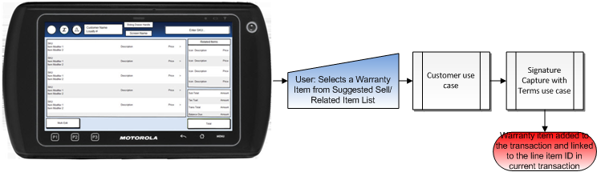

### Sell Warranty through Item Entry – Link Covered Item in Current Transaction

1. If the Warranty item is manually entered in Item Entry, the system checks if there are any eligible items that exist in the current transaction.
2. The system displays the list of eligible items with the option to add different covered items.
3. The user selects a covered item in the current transaction.
4. The system completes the remaining process to add the warranty item to the transaction.
5. The warranty item is linked to the covered item via line item ID from current transaction

**Note**: The process is the same for a bundled warranty item, with the exception that the system requires multiple covered items to be selected.

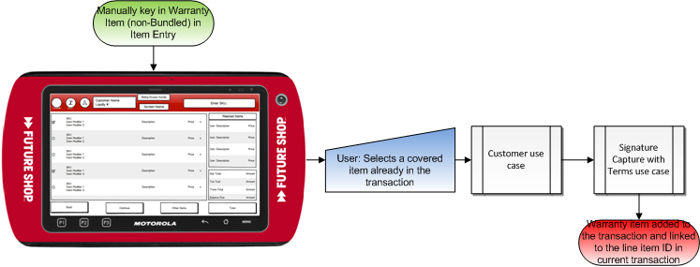

### No Eligible Items Exist in Current Transaction

1. If the Warranty item is manually entered in Item Entry, the system checks if there are any eligible items that exist in the current transaction.
2. The system determines that no eligible items exist in the transaction.
3. The system prompts for the covered item; the operator enters a covered item and accepts the entry.
4. The system prompts for the transaction key; the operator enters the transaction key and accepts the entry.
5. The system receives transaction details and determines that the covered item is in the transaction.
6. The system completes the remaining process to add the warranty item to the transaction.
7. The warranty item is linked to the covered item via line item ID from current transaction

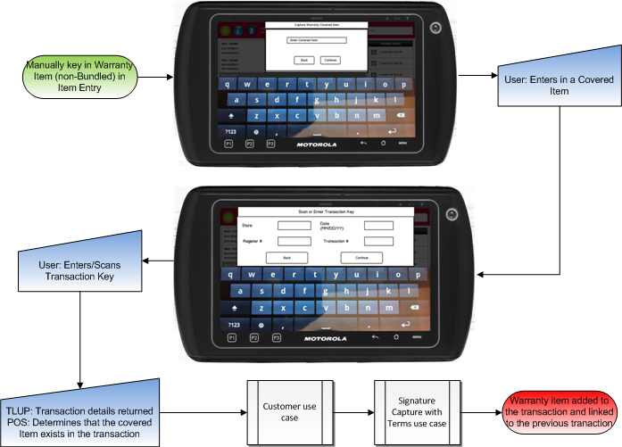

### Sell Warranty through Item Entry – Link Covered Item to Previous Transaction

1. If the Warranty item is manually entered in Item Entry, the system checks if there are any eligible items that exist in the current transaction.
2. The system displays the list of eligible items with the option to add different covered items.
3. The user selects to add different covered items.
4. The system prompts for the covered item; the operator enters a covered item and accepts the entry.
5. The system prompts for the transaction key; the operator enters the transaction key and accepts the entry.
6. The system receives transaction details and determines that the covered item is in the transaction.
7. The system completes the remaining process to add the warranty item to the transaction.
8. The warranty item is linked to the covered item via line item ID from current transaction.

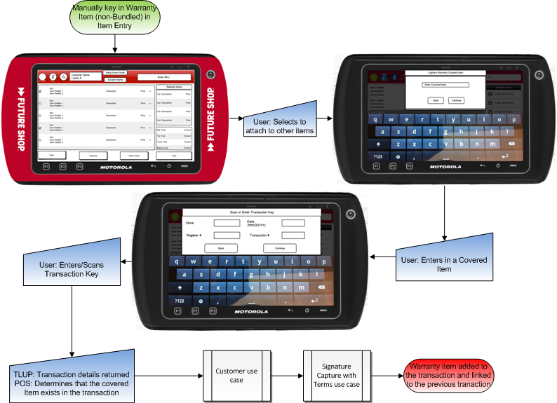

### Sell Bundled Warranty through Item Entry – Link Covered Item in Current Transaction

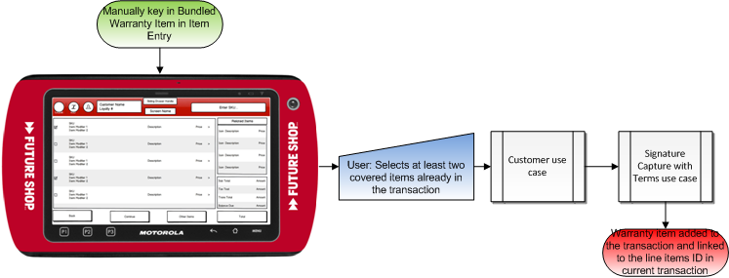

### Sell Bundled Warranty through Item Entry – Link Covered Item in Previous Transaction

The system follows same process as for regular Warranty item, with the except that the system displays the Enter Bundled Covered Item screen that has the ability to enter multiple covered items and at least two covered items are required are to be selected.

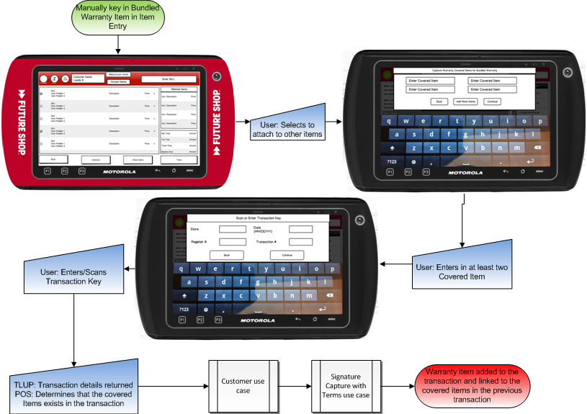

### Sell Warranty through Item Entry – Previous Transaction Already Captured in Transaction

1. If the Warranty item is manually entered in Item Entry, the system checks if there are any eligible items that exist in the current transaction.
2. The system displays the list of eligible items with the option to add different covered items.
3. The user selects to add different covered items.
4. The system prompts for the covered item; the operator enters a covered item and accepts the entry.
5. If the transaction already contains a Warranty-Covered Item link to a previous transaction, any other warranty item that is added to the transaction and will require a link to a previous transaction may only be linked to the already captured previous transaction. The system does not prompt to capture transaction information, it will automatically check the already transaction details if the entered covered item(s) are in the transaction.
6. The system determines that the covered item(s) is in the previous transaction.
7. The system completes the remaining process to add the warranty item to the transaction.
8. The warranty item is linked to the covered item via line item ID from current transaction.

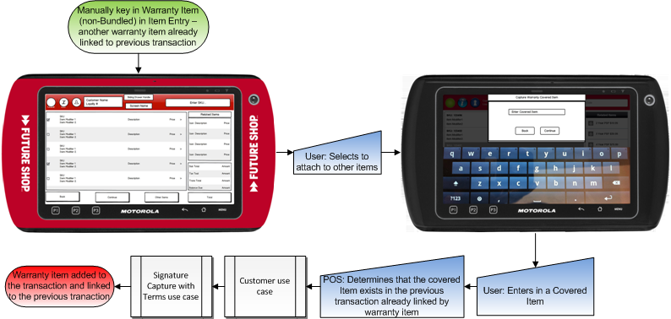

### Covered Item not in Previous Transaction

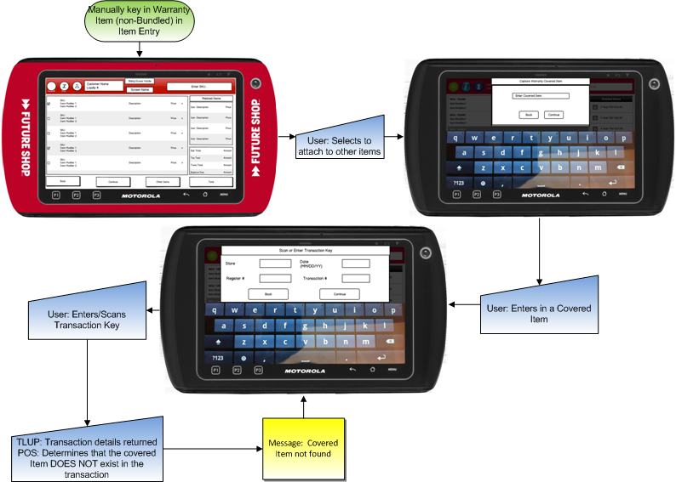

### Covered Item Not Eligible for Warranty

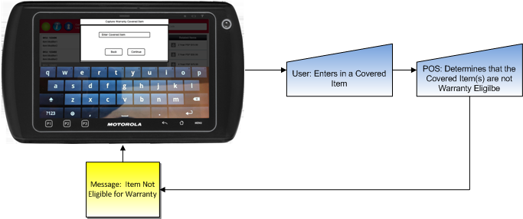

### Item Already Covered in the Transaction

The system checks any warranty-covered item links already linked in the transaction before applying a new link. In the case below a link was made from Covered Item A in Transaction 1 to Warranty Item B in Transaction 2. If the user enters in Warranty Item C in Transaction 2 and enter sin Covered Item A as the covered item, the system will attempt to find another Covered Item A in the Transaction 1. Since Covered Item A is already linked to Warranty Item B, that item is not eligible to be linked to Warranty Item C. If there is not a second Covered Item A in Transaction 1, the system will display a message that the Item is already covered.

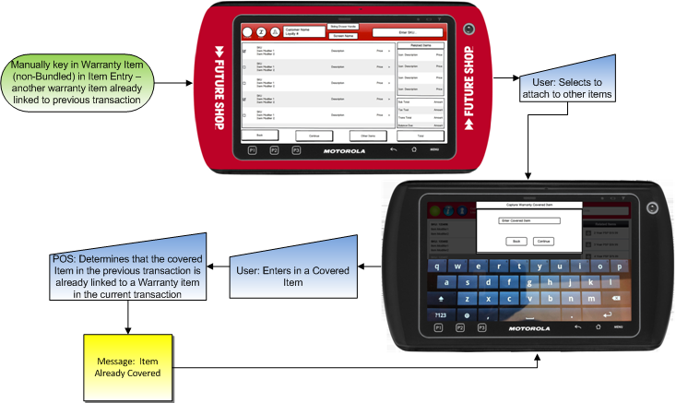

### Previous Transaction Not Found

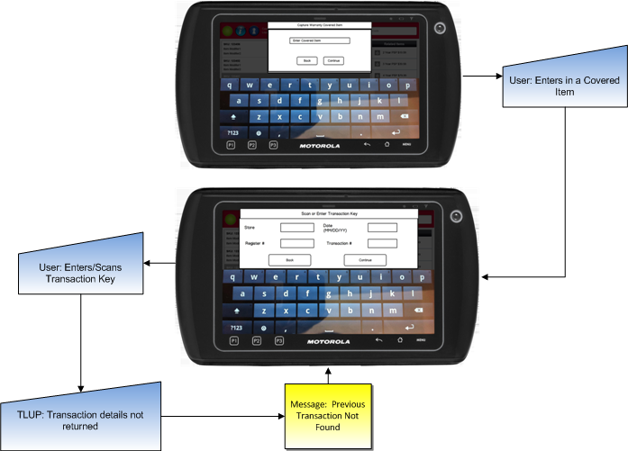

## Item Entry

Warranty items are displayed in the Suggested Sell area of the item entry screen.

### Mockup without Warranty items

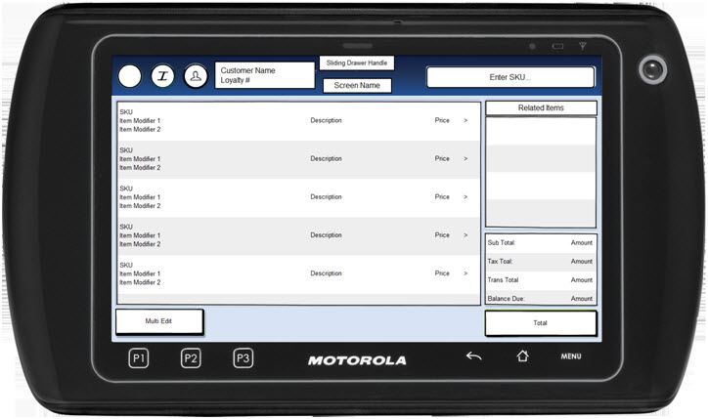

### Mockup with Warranty Items

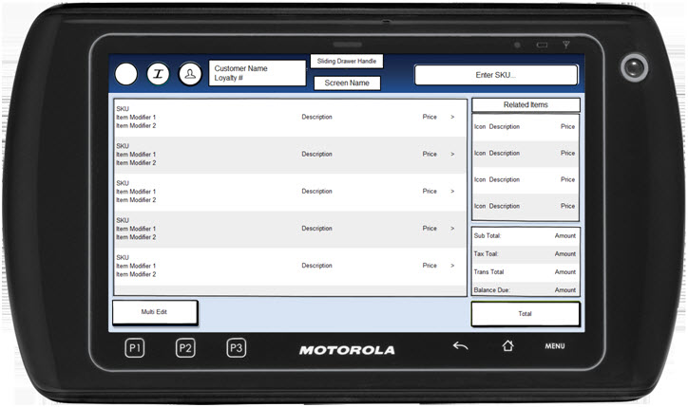

### Instruction Text

|  |
| --- |
| **Instructions** |
| None |

### Navigation/Menu Keys

|  |  |  |  |
| --- | --- | --- | --- |
| **Label** | **State** | **Next Screen** | **Notes** |
| Information | Enabled | Information | None |
| Item Entry | See Note | Item Entry | Scanner and keyboard are valid entry methods |
| Sliding Drawer Handle | Enabled | Tran Modify use case | None |
| Suggested Sell | See Notes | Sale use case | * Item selected by tap * Swipe up or down to see additional items (if applicable) * If no suggested sell list, the area is left blank |
| Total | See Notes | Tender use case | Enabled once a transaction is in progress |

### Data/Input Fields

|  |  |  |  |  |  |  |
| --- | --- | --- | --- | --- | --- | --- |
| **Label** | **Editable** | **Req’d?** | **Data Type** | **Min**  **Length** | **Max**  **Length** | **Notes** |
| SKU | No | N/A | Numeric | 1 | 8 | Display Only |
| Price | No | N/A | Currency | 4 | 9 | Display Only |
| Description | No | N/A | Text | 1 | 32 | Display Only |
| Deal Indicator | No | N/A | Text | 1 | 1 | Display Only |
| Subtotal: | No | N/A | Currency | 4 | 9 | Display Only |
| Tax Total: | No | N/A | Currency | 4 | 9 | Display Only |
| Total: | No | N/A | Currency | 4 | 9 | Display Only |
| Balance Due | No | N/A | Currency | 4 | 9 | Display Only |

### Reason Codes

|  |  |  |
| --- | --- | --- |
| **Reason Code** | **Valid Values** | **Default Value** |
| None |  |  |

### Information

|  |  |
| --- | --- |
| **Description** | This message is displayed when the operator selects the information icon on the Item Entry screen. Once selected, the system displays a message containing the register number and the transaction number (not the entire four part key). Acknowledging the message returns the operator to the Item Entry screen. The text is center aligned within the message and <Number> is replaced by the actual register and transaction number. |
| **Message** | Operator <user name>  Register <Number>  Transaction <Number, leave blank if not assigned>  Transaction Salesperson <Entered ID, leave blank if not captured> |
| **Key prompt** | OK |
| **Notes** | None |

### Item Already Covered

|  |  |
| --- | --- |
| **Description** | This message appears after eligibility has been validated and the covered item already has a linked warranty item. Acknowledging the message ends the use case and the warranty item is not added to the transaction. |
| **Message** | The covered item is linked to a warranty. A new warranty item cannot be sold. |
| **Key prompt** | OK |
| **Notes** | Configurable message |

## Item Entry – Warranty

The Item Entry – Warranty screen is displayed when the operator sells a bundled warranty item from the suggested sell list or if warranty item is sold through Item Entry instead of Suggested Sell list. The screen prompts the operator to select the eligible items in the transaction or to enter in Other Items from a previous transaction. The system displays only those items that are eligible to be covered by the warranty and those items not already linked to a warranty item. The eligible items are displayed in the order they were added to the transaction.

### Mockup

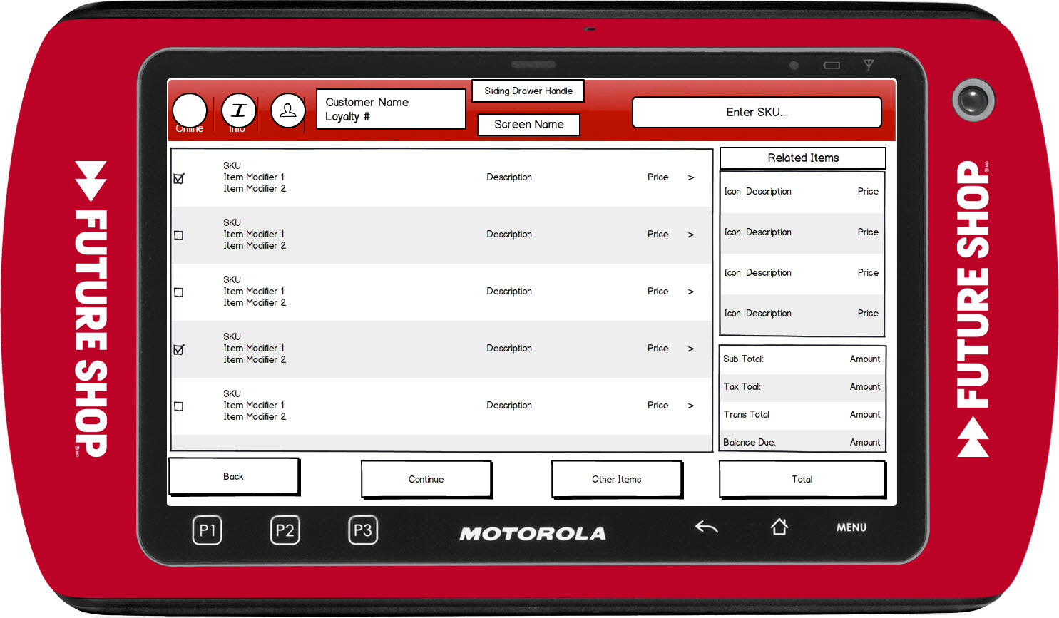

Figure 1: Item Entry – Select Warranty Covered Item

### Instruction Text Enhancements

|  |
| --- |
| **Instructions** |
| None |

### Navigation/Menu Key Enhancements

|  |  |  |  |
| --- | --- | --- | --- |
| **Label** | **State** | **Next Screen** | **Notes** |
| Back | Enabled | Sale use case | None |
| Continue | See Notes | * Selected Items for non-bundled: Sell Warranty use case, Customer Capture * Selected Items within Bundled Banding: Sell Warranty use case, Customer Capture * Selected Items outside Bundled Banding: Eligibility Not Met | Bundled Warranty Item: Enabled when at least two items has been checked.  Non-bundled Warranty Item: Enabled when at least one item has been checked. |
| Other Items | Enabled | * Non-Bundled Warranty: Enter Covered Item * Bundled Warranty: Enter Covered Item for Bundled Warranty | None |

### Data/Input Field Enhancements

|  |  |  |  |  |  |  |
| --- | --- | --- | --- | --- | --- | --- |
| **Label** | **Editable** | **Req’d?** | **Data Type** | **Min**  **Length** | **Max**  **Length** | **Notes** |
| Check Box by Item | Yes | See Notes | N/A | N/A | N/A | All items that are eligible to be covered by a warranty item.  For Bundled Warranty items, at least two items must be selected. |

### Reason Code Enhancements

|  |  |  |
| --- | --- | --- |
| **Reason Code** | **Valid Values** | **Default Value** |
| None |  |  |

### Bundled Warranty Eligibility Not Met

|  |  |
| --- | --- |
| **Description** | This message appears if the selected items are not within the bundled warranty’s banding. Acknowledging the message ends the use case and the warranty item is not added to the transaction. |
| **Message** | The bundled warranty eligibility requirements not met. |
| **Key prompt** | OK |
| **Notes** | Configurable message |

## Enter Covered Item

The Enter Covered Item screen is displayed when the operator sells a warranty item through item entry instead of through suggested sell. The screen prompts the entry of an item eligible to be sold with warranty item. Scanning is an implied enter.

### Mockup

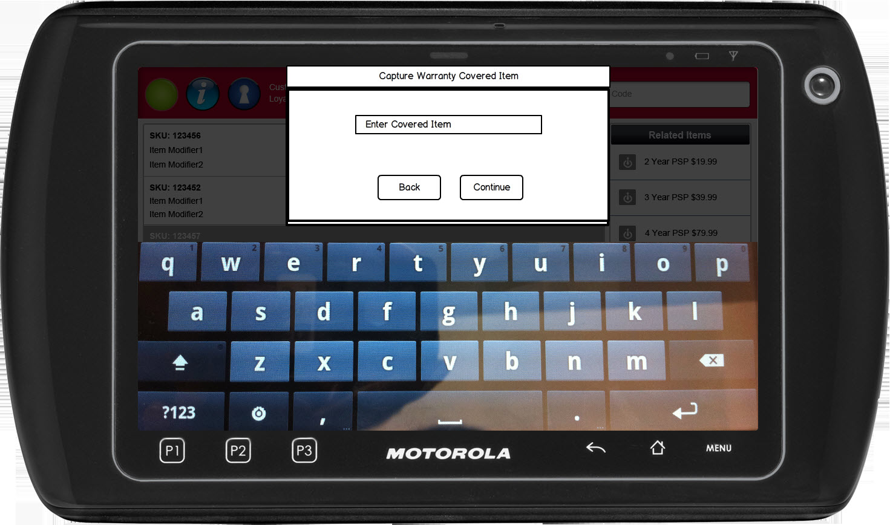

### Instruction Text

|  |
| --- |
| **Instructions** |
| None |

### Navigation/Menu Keys

|  |  |  |  |
| --- | --- | --- | --- |
| **Label** | **State** | **Next Screen** | **Notes** |
| Back | Enabled | * Sale use case | None |
| Continue | See notes | * Covered Item not Warranty Eligible: Item not Eligible for Warranty * Covered Item in Current Transaction: Warranty Use Case * Covered Item not in current transaction: Enter Transaction Information | Enabled upon data entry |

### Data/Input Fields

|  |  |  |  |  |  |  |
| --- | --- | --- | --- | --- | --- | --- |
| **Label** | **Editable** | **Req’d?** | **Data Type** | **Min**  **Length** | **Max**  **Length** | **Notes** |
| Enter Covered Item | Yes | Yes | Numeric | 1 | 8 |  |

### Reason Codes

|  |  |  |
| --- | --- | --- |
| **Reason Code** | **Valid Values** | **Default Value** |
| None |  |  |

### Item not Eligible for Warranty

|  |  |
| --- | --- |
| **Description** | This message appears when a warranty item is sold through item entry and the covered item that is entered is not eligible to be linked to a warranty item. |
| **Message** | The covered item is not eligible to be linked to a warranty item. |
| **Key prompt** | OK |
| **Notes** | Configurable message |

### Covered Item not Found

|  |  |
| --- | --- |
| **Description** | This message appears when the covered item cannot be found in the transaction – either in current transaction or in previous transaction. |
| **Message** | The covered item is not found. |
| **Key prompt** | OK |
| **Notes** | Configurable message |

### Item Already Covered

|  |  |
| --- | --- |
| **Description** | This message appears after eligibility has been validated and the covered item already has a linked warranty item. Acknowledging the message ends the use case and the warranty item is not added to the transaction. |
| **Message** | The covered item is linked to a warranty. A new warranty item cannot be sold. |
| **Key prompt** | OK |
| **Notes** | Configurable message |

## Enter Covered Item for Bundled Warranty

The enter covered item for bundled warranty screen is displayed when the operator sells a bundled warranty item either through item entry instead of through suggested sell. The screen prompts the entry of multiple items that the warranty covers, for example a washer and dryer. Scanning is an implied enter for the current field and will move to the next enter item text box. A minimum of two items needs to be entered to continue.

### Mockup

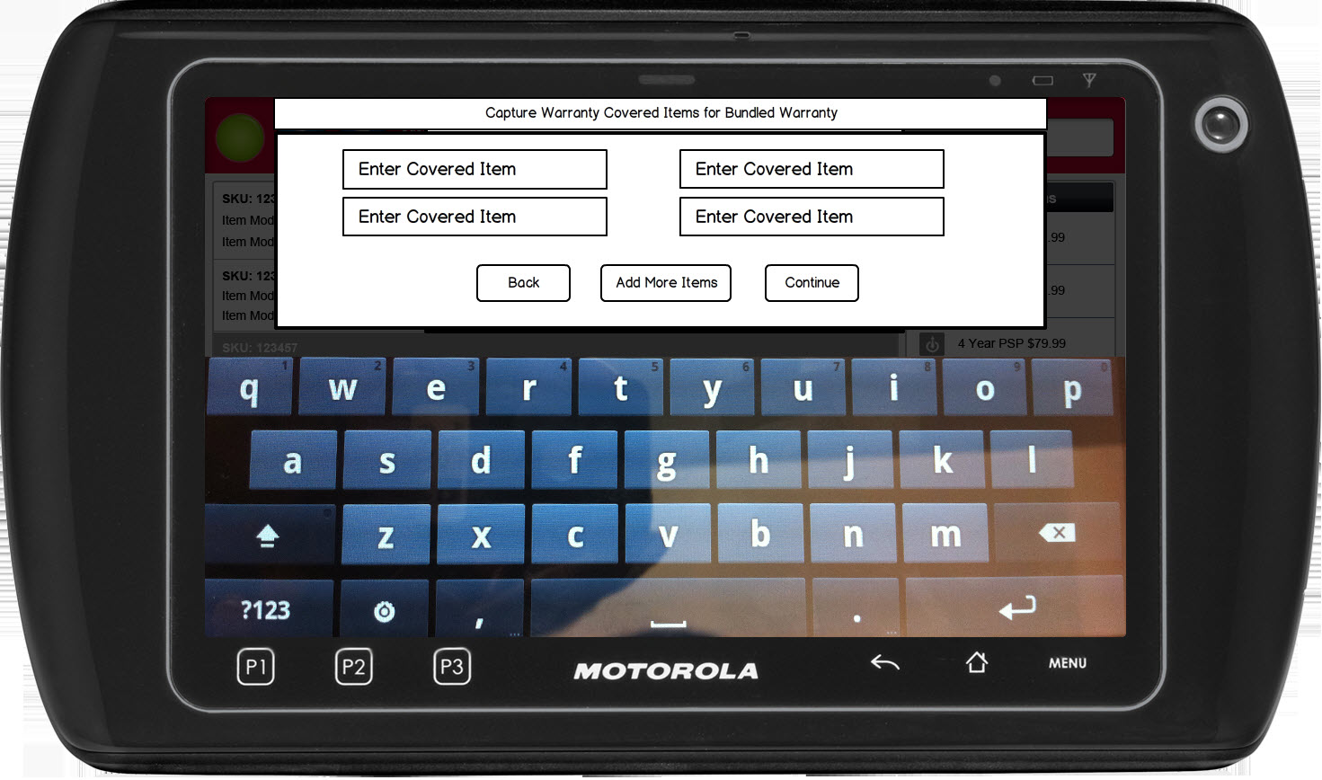

### Instruction Text

|  |
| --- |
| **Instructions** |
| None |

### Navigation/Menu Keys

|  |  |  |  |
| --- | --- | --- | --- |
| **Label** | **State** | **Next Screen** | **Notes** |
| Back | Enabled | * Sale use case | None |
| Continue | See notes | * At least one Covered Item not Warranty Eligible: Item not Eligible for Warranty * Covered Items in Current Transaction: Warranty Use Case * Covered Items not in current transaction: Enter Transaction Information | Enabled upon data entry of at least two covered items |

### Data/Input Fields

|  |  |  |  |  |  |  |
| --- | --- | --- | --- | --- | --- | --- |
| **Label** | **Editable** | **Req’d?** | **Data Type** | **Min**  **Length** | **Max**  **Length** | **Notes** |
| Enter Covered Item | Yes | Yes | Numeric | 1 | 8 | None |

### Reason Codes

|  |  |  |
| --- | --- | --- |
| **Reason Code** | **Valid Values** | **Default Value** |
| None |  |  |

### Item not Eligible for Warranty

|  |  |
| --- | --- |
| **Description** | This message appears when a warranty item is sold through item entry and the covered item that is entered is not eligible to be linked to a warranty item. |
| **Message** | The covered item is not eligible to be linked to a warranty item. |
| **Key prompt** | OK |
| **Notes** | Configurable message |

### Covered Item not Found

|  |  |
| --- | --- |
| **Description** | This message appears when the covered item cannot be found in the transaction – either in current transaction or in previous transaction. |
| **Message** | The covered item is not found. |
| **Key prompt** | OK |
| **Notes** | Configurable message |

### Item Already Covered

|  |  |
| --- | --- |
| **Description** | This message appears after eligibility has been validated and the covered item already has a linked warranty item. Acknowledging the message ends the use case and the warranty item is not added to the transaction. |
| **Message** | The covered item is linked to a warranty. A new warranty item cannot be sold. |
| **Key prompt** | OK |
| **Notes** | Configurable message |

## Enter Transaction Information

The enter transaction information screen is displayed when the covered items are not in the current transaction and the lookup previous transaction parameter is enabled. The screen allows the scanning of the barcode to accept the transaction key along with keying in the 4 parts. All four fields are required.

Previous transaction must be from the same brand as the current store. Future Shop stores brand is 11 and Best Buy stores brand is 10.

### Mockup

Note: The Enter Transaction Key screen used for other parts of MPOS is used for this process. Below is a general mockup.

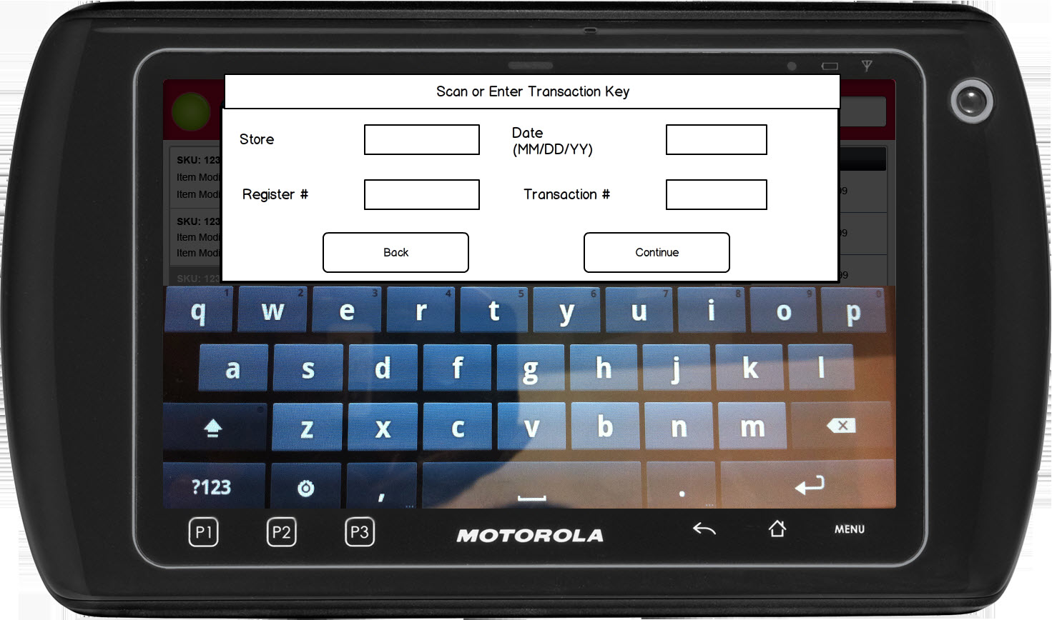

### Instruction Text

|  |
| --- |
| **Instructions** |
| None |

### Navigation/Menu Keys

|  |  |  |  |
| --- | --- | --- | --- |
| **Label** | **State** | **Next Screen** | **Notes** |
| Back |  | * Non-bunlded Item: Enter Covered Item * Bundled Item: Enter Covered Item for Bundled Warranty | None |
| Continue |  | * Scan error: Invalid Transaction * Previous Transaction not from same brand: Invalid Transaction * Transaction found with Covered Item in Transaction: Sale use case * Transaction Not Found response: Transaction Not Found * Transaction found but covered item not in transaction: Covered Item Not in Transaction | None |
| NA | Scan Receipt Barcode | * Scan error: Invalid Transaction * Previous Transaction not from same brand: Invalid Transaction * Transaction found with Covered Item in Transaction: Sale use case * Transaction Not Found response: Transaction Not Found * Transaction found but covered item not in transaction: Covered Item Not in Transaction | None |

### Data/Input Fields

|  |  |  |  |  |  |  |
| --- | --- | --- | --- | --- | --- | --- |
| **Label** | **Editable** | **Req’d?** | **Data Type** | **Min**  **Length** | **Max**  **Length** | **Notes** |
| Store | Yes | Yes | Numeric | 1 | 4 | None |
| Date | Yes | Yes | Date | 1 |  | Format is MM/DD/YY |
| Register Number | Yes | Yes | Numeric | 1 | 4 | None |
| Transaction Number | Yes | Yes | Numeric | 1 | 6 | None |

### Reason Codes

|  |  |  |
| --- | --- | --- |
| **Reason Code** | **Valid Values** | **Default Value** |
| None |  |  |

### Invalid Transaction

|  |  |
| --- | --- |
| **Description** | The Invalid Transaction message displays when the receipt that was scanned where the barcode on the receipt could not be read or transaction is not in the same brand as the current transaction. Upon acknowledging the message, the system returns to the Enter Transaction Key screen. |
| **Message** | Transaction is invalid |
| **Key prompt** | OK |
| **Notes** | Configurable database message |

### Previous Transaction Too Old

|  |  |
| --- | --- |
| **Description** | This message is displayed if the entered transaction is past the Previous Transaction Number of Days |
| **Message** | The previous transaction is too old. Continue with Manager Override? |
| **Key prompt** | * Yes: The system executes manager override use case * No: The system returns to the Enter Transaction Key screen |
| **Notes** | Configurable message |

### Transaction Not Found

|  |  |
| --- | --- |
| **Description** | This message appears when the previous transaction cannot be found by the external system or if received an offline/timeout from the external system. |
| **Message** | Transaction not found. |
| **Key prompt** | OK |
| **Notes** | Configurable message |

### Covered Item not Found

|  |  |
| --- | --- |
| **Description** | This message appears when the covered item cannot be found in the transaction – either in current transaction or in previous transaction. |
| **Message** | The covered item is not found. |
| **Key prompt** | OK |
| **Notes** | Configurable message |

# *Business Sign Off*

|  |  |  |
| --- | --- | --- |
| **Name** | **Organization** | **Date** |
|  |  |  |

# *Revision History*

|  |  |  |  |
| --- | --- | --- | --- |
| **Reviser** | **Revision** | **Date** | **Version** |
| Amy Lackas | Initial document created | 03/26/2013 | 1.0 |
| Amy Lackas | Updates after internal review | 04/01/2013 | 1.1 |
| Amy Byers | Added that items with a quantity greater than 1 are not eligible for warranties.  System does not validate quantity on previous transactions. | 3/20/2015 | 1.2 |
| Amy Byers | Added Skip PSP PRP Validation IBH flag | 4/1/2015 | 1.3 |

# *Appendix A: Glossary*

|  |  |
| --- | --- |
| **Term** | **Definition** |
| Covered item | Item to be covered by a warranty item |
| PSP | Product Service Plan |
| PRP | Product Replacement Plan |
| IBH | International Business Hierarchy |